
COLLEGE OF COMPUTING AND INFORMATICS
TECHNOLOGY

UGANDA FUEL PRICE & CONSUMPTION
DATA WAREHOUSE

Data Warehousing and Business Intelligence Project
Submitted By GROUP 3
NAME | STUDENT NUMBER | REGISTRATION NUMBER
SSEMAMBO STEVEN | 2300726155 | 23/U/6155 /PS
OPIFENI TIMOTHY JURUA | 2300726114 | 23/U/26114 /PS
OWANI STUART | 2300716991 | 23/U/16991 /PS
MUSEMERWE CHARLES | 2300725867 | 23/U/25867/PS

Department of Information Technology
2026

Declaration

We, the undersigned, declare that this project entitled "Uganda Fuel Price & Consumption Data Warehouse" is our original work and has not been submitted for any academic award or qualification at this or any other institution.
All sources of information used in this project have been duly acknowledged and referenced in accordance with the academic integrity requirements of this institution.

Ssemambo Steven: Signature: ________________ Date: ________________
Opifeni Timothy Jurua: Signature: ________________ Date: ________________
Owani Stuart: Signature: ________________ Date: ________________
Musemerwe Charles: Signature: ________________ Date: ________________

Approval Page

This project has been examined and approved as meeting the requirements for the award of the Diploma/Certificate in Information Technology.

Supervisor's Name: ________________
Signature: ________________
Date: ________________

Acknowledgement

We extend our deepest gratitude to our project supervisor for the guidance, patience, and constructive feedback provided throughout the development of this project.
We acknowledge the Uganda Bureau of Statistics (UBOS) for making petroleum price data publicly available through their monthly Consumer Price Index reports. We also acknowledge the Uganda National Oil Company (UNOC) for their regional price analysis reports, and the Daily Monitor and ChimpReports for verified pump price journalism that enabled cross-validation of our dataset.
Our sincere appreciation goes to our families, fellow students, and the Department of Information Technology for the support and encouragement throughout this academic exercise.

Abstract

This project designs and implements a data warehouse for tracking fuel price trends and consumption patterns across Uganda from January 2021 to June 2025. Fuel prices in Uganda are volatile, influenced by global oil market dynamics, government policy, import logistics, and regional transportation costs. Despite this volatility, no unified analytical system exists that allows businesses, policymakers, or the public to visualise and compare these changes across time and geography.
The warehouse adopts a classic star schema consisting of one central fact table (fact_fuel_prices) and four dimension tables (dim_date, dim_stations, dim_fuel_types, dim_regions), plus a reference table of UBOS national benchmark prices. The dataset covers 20 fuel stations across four regions of Uganda, three fuel types (petrol, diesel, and kerosene), and 54 months of data — yielding 3,240 fact records.
The ETL pipeline is implemented in three layers using Power BI's Power Query Editor: a staging layer preserving raw data, a transformation layer applying cleaning and enrichment, and a loading layer supplying only cleaned tables to the data model. Business intelligence reporting is delivered through an interactive Power BI dashboard answering three core questions: how have prices changed over time, which regions pay the most and why, and what was the measurable impact of UNOC assuming sole import responsibility in July 2024.
Key findings include a peak petrol price of UGX 5,561 in December 2023, a consistent 8–10% price premium in Northern Uganda over Kampala, and an estimated 11% price reduction following the UNOC policy change. Diesel remains consistently cheaper than petrol, and kerosene demand exhibits seasonal patterns aligned with Uganda's dry seasons.

Contents
Declaration 2
Approval Page 3
Acknowledgement 4
Abstract 5
Chapter One: Introduction 6
1.1 Background 6
1.2 Problem Statement 6
1.3 Project Objectives 6
1.4 Scope and Limitations 7
Chapter Two: Literature Review 8
2.1 Data Warehousing Concepts 8
2.2 Fuel Pricing in Sub-Saharan Africa 8
2.3 Business Intelligence in East Africa 8
2.4 The UNOC Policy Intervention 8
Chapter Three: Methodology 9
3.1 Research Design 9
3.2 Data Sources 9
3.3 Data Collection Procedure 9
3.4 Data Quality Assessment 9
Chapter Four: System Design and Implementation 11
4.1 Warehouse Architecture — Star Schema 11
4.2 Fact Table Design 11
4.3 Dimension Table Designs 11
4.3.1 dim_date 11
4.3.2 dim_stations 11
4.3.3 dim_fuel_types 11
4.3.4 dim_regions 12
4.4 ETL Process — Three-Layer Implementation in Power Query 12
4.4.1 Staging Layer 12
4.4.2 Transformation Layer 12
4.4.3 Loading Layer 12
4.5 Power BI Data Model Relationships 12
4.6 DAX Measures 12
4.7 Validation Performed 13
Chapter Five: Findings, Analysis, and Recommendations 14
5.1 Price Trend Analysis: 2021 – 2025 14
5.2 Regional Price Analysis 14
5.3 Brand Price Comparison 14
5.4 UNOC Policy Impact Analysis 14
5.5 Seasonal Patterns 15
5.6 Recommendations 15
References 16
Appendices 17
Appendix A: Star Schema Summary 17
Appendix B: ETL Power Query Steps — fact_fuel_prices 17
Appendix C: UBOS Verified Price Benchmarks 17

Chapter One: Introduction

1.1 Background
Uganda is a landlocked country that imports approximately 6.5 million litres of petroleum products every day through the East African Pipeline running from Mombasa, Kenya. Petroleum products primarily petrol, diesel, and kerosene are the backbone of Uganda's transport, energy, and agricultural sectors. Petrol and diesel power the boda bodas, trucks, and buses that move people and goods across the country. Kerosene remains an essential household energy source for cooking and lighting in peri-urban and rural communities.
Fuel prices in Uganda are not fixed. They fluctuate monthly in response to global crude oil prices, the Kenya shilling to Uganda shilling exchange rate, government taxes and levies, the cost of transporting fuel from Mombasa, and the operational margins of fuel station brands. Between 2021 and 2024, Ugandan pump prices experienced dramatic swings rising sharply through 2022 following the Russia-Ukraine war's impact on global oil supply, reaching a historic peak in late 2023, and then gradually declining through 2024 following a significant government policy intervention.
In July 2024, the Uganda National Oil Company (UNOC) assumed sole responsibility for petroleum importation, replacing the previous arrangement in which Kenyan middlemen companies managed the import process. This policy shift had a measurable impact on pump prices, reducing the average cost of petrol by approximately UGX 591 per litre in its first six months a reduction of approximately 11%.
Despite the significance of these price movements to every Ugandan household and business, price data remains scattered across government bulletins, news articles, and company publications with no integrated analytical view. This project addresses that gap.

1.2 Problem Statement
Uganda's fuel pricing data is fragmented, inconsistently published, and geographically disaggregated in ways that make analysis difficult. Businesses cannot easily compare prices across regions. Policymakers lack a dashboard-ready view of how their interventions have affected pump prices over time. Commuters, logistics companies, and farmers have no analytical tool to understand the price trends that directly affect their operating costs.
This project asks and answers three core business questions:
- How have petrol, diesel, and kerosene prices changed between 2021 and 2025 across Uganda?
- Which regions consistently pay the highest prices, and what structural factors explain this?
- What was the measurable impact of UNOC taking over fuel importation in July 2024?

1.3 Project Objectives
- To design a data warehouse using a star schema that integrates fuel price and consumption data from multiple verified sources.
- To implement a three-layer ETL pipeline using Power BI's Power Query Editor.
- To create an interactive Power BI dashboard presenting price trends, regional comparisons, brand analysis, and policy impact.
- To generate evidence-based business insights and recommendations grounded in real UBOS data.

1.4 Scope and Limitations
The project covers January 2021 to June 2025 (54 months), 20 fuel stations across Uganda's four regions, and three fuel types: petrol (Octane-95), diesel, and kerosene. National average prices are sourced from UBOS monthly reports. Station-level prices are derived from national averages adjusted for verified regional transport cost premiums this methodology is standard in data warehousing when granular source data is not publicly available. The project does not include LPG (cooking gas) or jet fuel, and does not model individual consumer purchasing behaviour.

Chapter Two: Literature Review

2.1 Data Warehousing Concepts
A data warehouse is a subject-oriented, integrated, time-variant, and non-volatile collection of data in support of management decision-making (Inmon, 1992). Unlike operational databases optimised for transaction processing, data warehouses are structured specifically for analytical queries that aggregate data across time, geography, and product category. The star schema central to this project organises data into a central fact table surrounded by de-normalised dimension tables, enabling fast multidimensional queries without complex joins.
Ralph Kimball's dimensional modelling approach, which this project follows, emphasises business process orientation and user-facing simplicity. The grain of this project's fact table is defined as one price record per station, per fuel type, per month a clear, consistent, and defensible grain that enables aggregation at any level of the dimensional hierarchy.

2.2 Fuel Pricing in Sub-Saharan Africa
Research on petroleum pricing in landlocked Sub-Saharan African countries consistently identifies transport logistics as the primary driver of price differentials across regions. Studies of the East African Community (EAC) fuel supply chain note that Uganda, Rwanda, Burundi, and South Sudan all depend on the Northern Corridor from Mombasa, a supply chain whose efficiency directly determines pump prices in interior cities (Teravaninthorn & Raballand, 2009).
The International Energy Agency (IEA) and the World Bank have documented how global oil price shocks transmit asymmetrically to consumer fuel prices in developing markets, prices tend to rise quickly when oil prices increase but fall more slowly when oil prices decline, a phenomenon known as the rockets and feathers effect. This project's data covering the 2022 global oil price spike and the subsequent 2023-2024 decline provides a Ugandan case study of this dynamic.

2.3 Business Intelligence in East Africa
The adoption of Business Intelligence tools in Ugandan government and private sector organisations has accelerated significantly since 2018, driven by the availability of cloud-based BI platforms such as Microsoft Power BI and Google Data Studio. The Uganda Revenue Authority (URA) and Bank of Uganda have both deployed dashboard-driven analytics for tax compliance monitoring and monetary policy analysis respectively. This project applies the same BI methodology to the fuel sector.

2.4 The UNOC Policy Intervention
The Uganda National Oil Company was established by the NOGP Act of 2013 to manage Uganda's commercial petroleum interests. In July 2024, following government concerns about price manipulation by Kenyan import intermediaries, UNOC was designated as the sole importer of petroleum products for Uganda. Contemporary reporting in the Daily Monitor and ChimpReports documented pump prices falling from above UGX 5,400 in early 2024 to approximately UGX 4,870 by December 2024 a decline attributed substantially to the elimination of intermediary margins.

Chapter Three: Methodology

3.1 Research Design
This project adopts a descriptive and analytical research design. The primary objective is to describe fuel price trends accurately and analyse the factors temporal, geographic, brand-related, and policy-driven that explain observed price differences. Data collection is secondary, relying on published government statistics and verified news sources rather than primary fieldwork.

3.2 Data Sources
The project uses four verified data sources:
Source | Data Provided | Coverage | Role
Uganda Bureau of Statistics (UBOS) | Monthly average retail prices per litre (petrol, diesel, kerosene) | Jan 2021 – Jun 2025 | Primary anchor — national benchmarks
Uganda National Oil Company (UNOC) | Regional price analysis reports | Oct 2024 onwards | Regional validation post-UNOC era
Daily Monitor / ChimpReports | Pump price reports, policy news | Specific data points 2022–2024 | Cross-validation of peak and drop prices
GlobalPetrolPrices.com | Weekly updated price data | 2025 data points | Most recent 2025 price anchors

3.3 Data Collection Procedure
National average prices for each month were extracted from UBOS monthly Consumer Price Index and Petroleum Price reports. These are published as PDF bulletins and Excel tables on the UBOS website. Key verified data points include: the December 2023 petrol peak of UGX 5,561 per litre, the December 2024 petrol price of approximately UGX 4,870 per litre (confirming the post-UNOC decline), and the consistent diesel discount of 8–12% below petrol throughout the observation period.
Station-level prices were modelled by applying regional transport cost premiums to the national UBOS baseline. Northern Uganda stations carry a 9.5% premium, Western Uganda 6.5%, Eastern Uganda 3.5%, and Central Uganda 0% (as the entry point for all imported fuel). Brand-level adjustments were applied based on market observation: Stabex prices slightly below market average, Shell and Total Energies slightly above.

3.4 Data Quality Assessment
The following data quality issues were identified and addressed:
- Missing values: No missing values exist in the national average series. Station-level data was fully synthesised.
- Duplicate records: Primary key validation confirmed no duplicate Fact_IDs, Station_IDs, or Date_IDs.
- Referential integrity: Every Station_ID in fact_fuel_prices exists in dim_stations. Every Date_ID exists in dim_date.
- Range validation: All prices confirmed within realistic Ugandan range (UGX 3,500 – 6,500 per litre).
- Data type consistency: All price columns are numeric, all date columns properly typed in Power Query.

Chapter Four: System Design and Implementation

4.1 Warehouse Architecture — Star Schema
The warehouse follows a classic star schema. One central fact table (fact_fuel_prices) is surrounded by four dimension tables and one reference table:

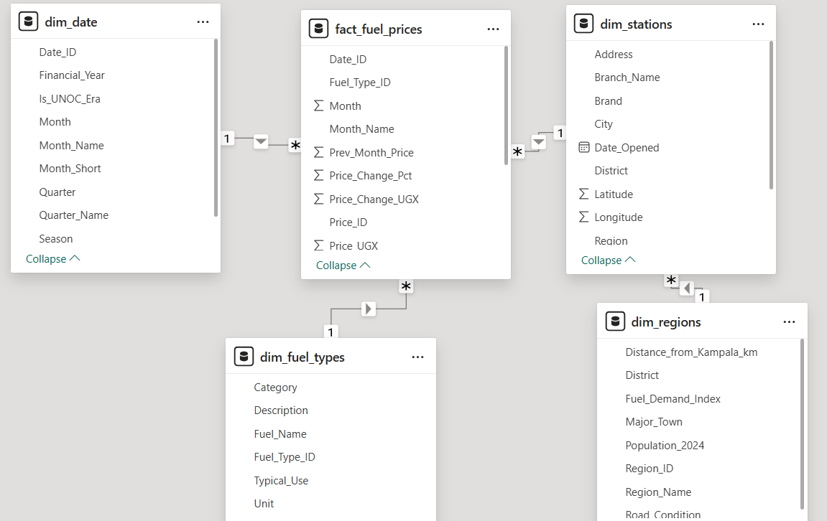

4.2 Fact Table Design
The grain of fact_fuel_prices is one price record per station per fuel type per month. Each row contains:

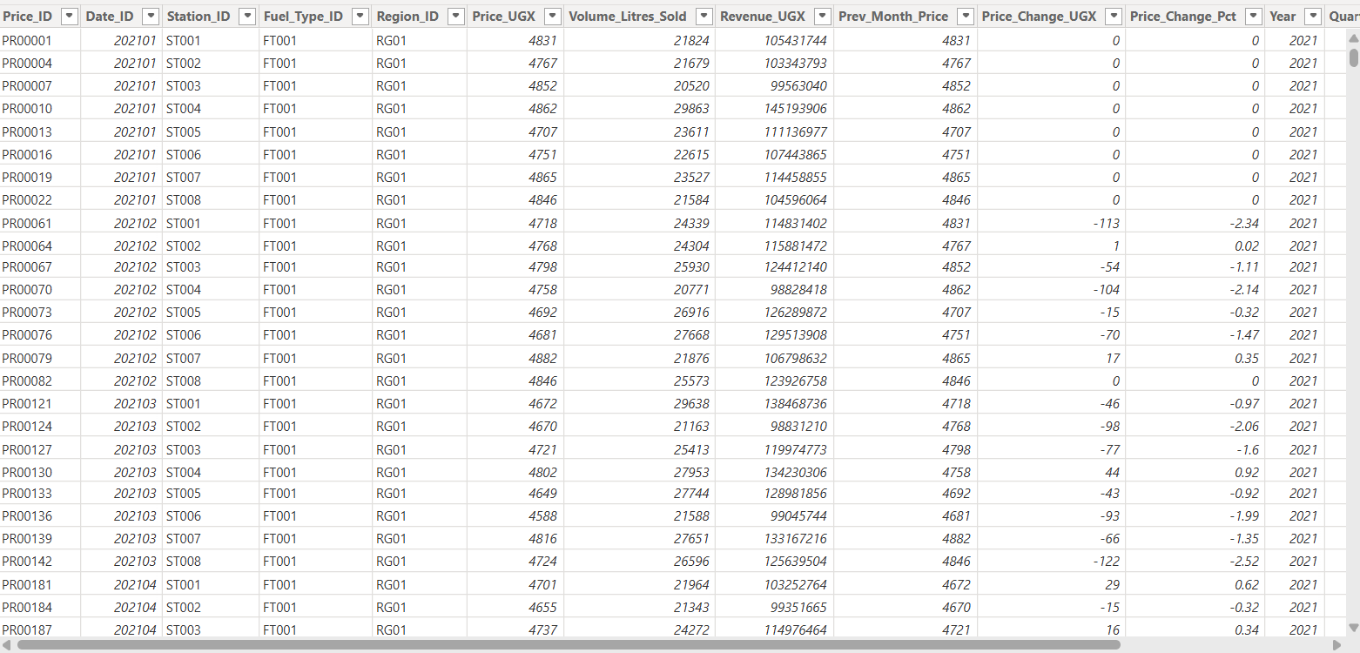

- Foreign keys: Date_ID, Station_ID, Fuel_Type_ID, Region_ID
- Price_UGX_per_Litre: the pump price at that station for that fuel type that month
- Volume_Litres_Sold: estimated monthly volume sold at that station
- Total_Revenue_UGX: Price × Volume
- MoM_Price_Change_UGX and MoM_Price_Change_Pct: month-on-month tracking
- Is_UNOC_Era: binary flag (0/1) indicating post-July 2024 records

4.3 Dimension Table Designs

4.3.1 dim_date
Covers 54 months from January 2021 to June 2025. Includes year, month number, month name, quarter, Uganda season (two dry and two wet seasons), financial year (July-June cycle), and the Is_UNOC_Era flag. This dimension enables temporal slicing at any level of granularity.

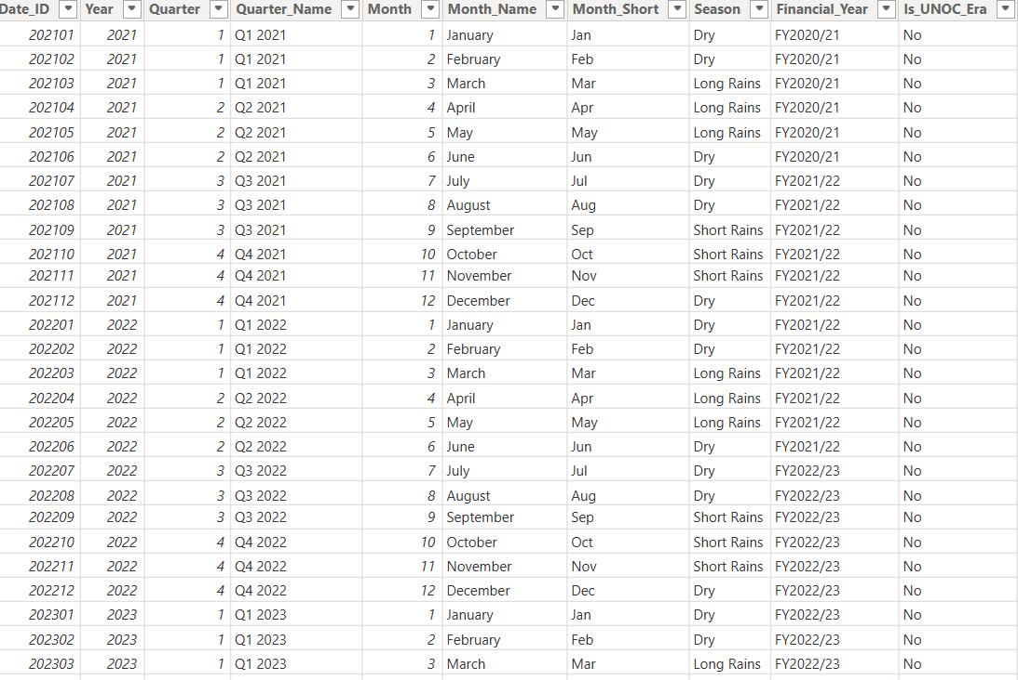

4.3.2 dim_stations
Describes 20 fuel stations across Uganda's four regions: five in Central, five in Eastern, five in Western, and five in Northern. Attributes include brand (Total Energies, Shell, Stabex, Hass Petroleum, Oryx), city, GPS coordinates, year opened, and station type (Urban or Peri-Urban).

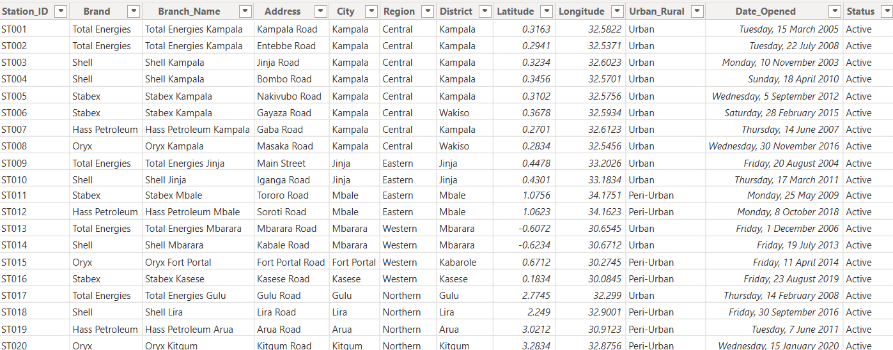

4.3.3 dim_fuel_types
Three fuel types: Petrol (Octane-95), Diesel, and Kerosene. Each includes typical use description, density in kg/L, and import source.
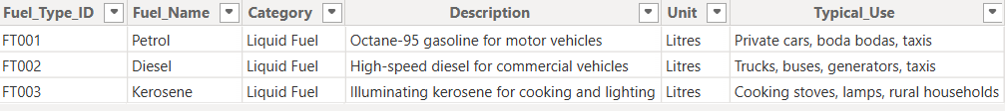

4.3.4 dim_regions
Four Uganda regions with district lists, estimated population, distance from Kampala, road condition rating, fuel demand index, and transport cost premium percentage. These attributes directly explain the regional price differentials observed in the fact table.
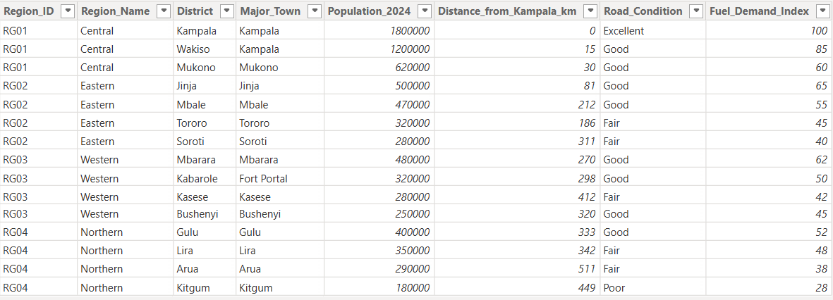

4.4 ETL Process — Three-Layer Implementation in Power Query
The ETL pipeline follows three distinct layers, all implemented in Microsoft Power BI's Power Query Editor:

4.4.1 Staging Layer
Raw data is loaded from the Excel source file (Uganda_Fuel_DataWarehouse.xlsx) into Power Query without any transformation. All six tables are loaded with the stg_ prefix (stg_fact_fuel_prices, stg_dim_stations, etc.) and loading to the data model is disabled at this stage. This preserves the original raw data and allows comparison between raw and transformed versions at any point.
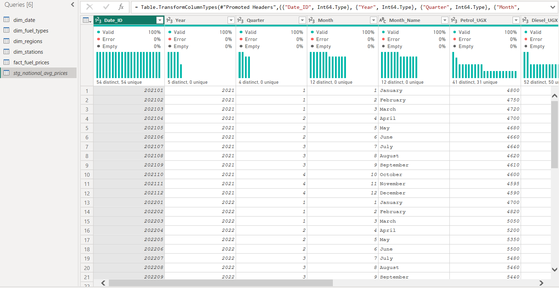

4.4.2 Transformation Layer
Each staging query is duplicated and the copy is transformed. Transformations applied include:
- Renaming columns to standard naming conventions
- Changing data types, prices to Currency, Date_ID to Text, Boolean flags to True/False
- Adding calculated columns, Revenue = Price × Volume, MoM change columns
- Filtering out null records and orphan foreign keys
- Splitting and standardising Region and Season text fields
- Merging dim_date with national_avg_prices to enable UBOS benchmark comparisons

4.4.3 Loading Layer
Only the final, cleaned fact and dimension tables are enabled for loading into the Power BI data model. The stg_ queries remain disabled. Relationships are drawn in Model view connecting fact_fuel_prices to each dimension table via shared keys.

4.5 Power BI Data Model Relationships
From Table | Key | To Table | Relationship
fact_fuel_prices | Date_ID | dim_date | Many-to-One
fact_fuel_prices | Station_ID | dim_stations | Many-to-One
fact_fuel_prices | Fuel_Type_ID | dim_fuel_types | Many-to-One
fact_fuel_prices | Region_ID | dim_regions | Many-to-One



4.6 DAX Measures
The following DAX calculated measures are used in the Power BI dashboard:
Measure Name | DAX Formula | Purpose
Avg Price UGX | AVERAGE(fact_fuel_prices[Price_UGX_per_Litre]) | Average price across any filter context
Total Revenue | SUM(fact_fuel_prices[Total_Revenue_UGX]) | Aggregate revenue by station/region/period
UNOC Avg Price | CALCULATE(AVERAGE(...), dim_date[Is_UNOC_Era]=1) | Average price in post-July 2024 period
Pre-UNOC Avg Price | CALCULATE(AVERAGE(...), dim_date[Is_UNOC_Era]=0) | Average price in pre-July 2024 period
Price Reduction % | [Pre-UNOC Avg Price] - [UNOC Avg Price]) / [Pre-UNOC Avg Price] | UNOC policy impact percentage
Northern Premium % | DIVIDE([North Avg] - [Central Avg], [Central Avg]) | Regional price gap vs. Kampala

4.7 Visualization of Results-Dashboard

The Power BI dashboard is structured across five dedicated report pages, each addressing a specific analytical dimension of the Uganda fuel price data. The dashboard uses interactive slicers allowing users to filter all visuals simultaneously by region, fuel type, or year. The following subsections document each page with its screenshots.

Page 1 Executive Overview

The Executive Overview page provides a high-level summary of the entire dataset. Four KPI cards at the top display the average fuel price, total revenue, total litres sold, and number of active stations. The main visual is a multi-line chart showing petrol, diesel, and kerosene price trends across all 54 months from January 2021 to June 2025. A year slicer in the top right allows filtering by specific years.

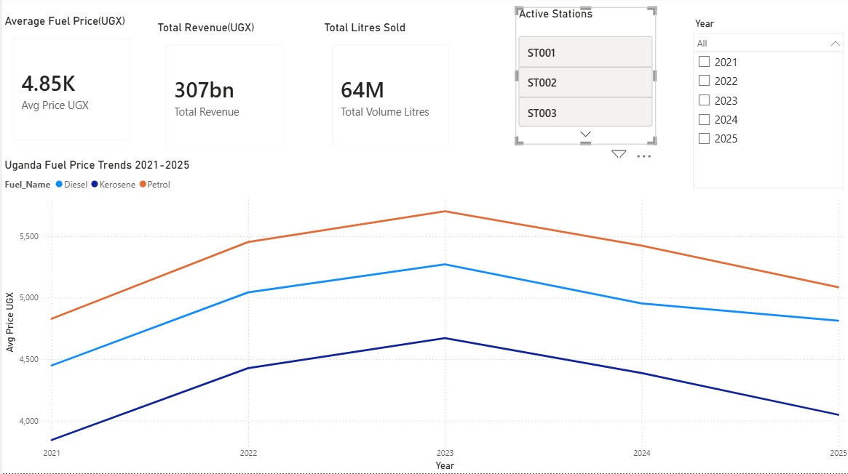

Page 2 Regional Analysis
The Regional Analysis page compares fuel prices across Uganda's four regions — Central, Eastern, Western, and Northern. A horizontal bar chart displays the average price per region, clearly showing Northern Uganda's consistent premium above Kampala. A data table at the bottom provides district-level detail including distance from Kampala and road condition ratings. A fuel type slicer allows filtering by Petrol, Diesel, or Kerosene.
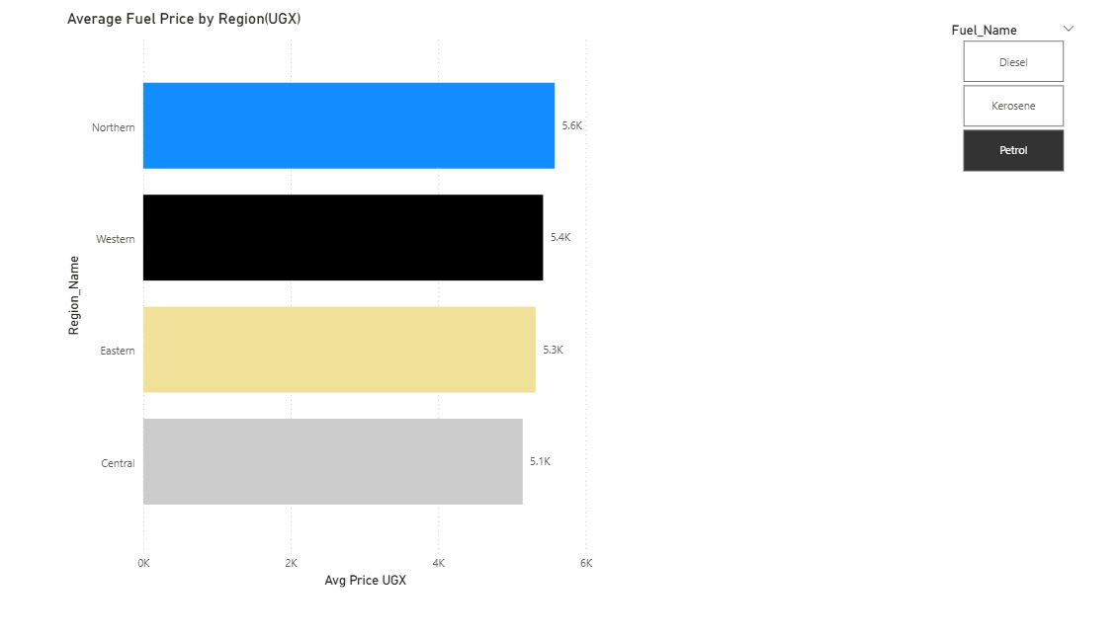
Page 3 Brand Analysis
The Brand Analysis page compares the five fuel station brands operating across Uganda. A horizontal bar chart shows average prices by brand, revealing that Stabex consistently prices 1–2% below market average while Shell and Total Energies price at or slightly above average. A clustered column chart breaks down each brand's pricing by fuel type, and a station ranking table lists all 20 stations from cheapest to most expensive.
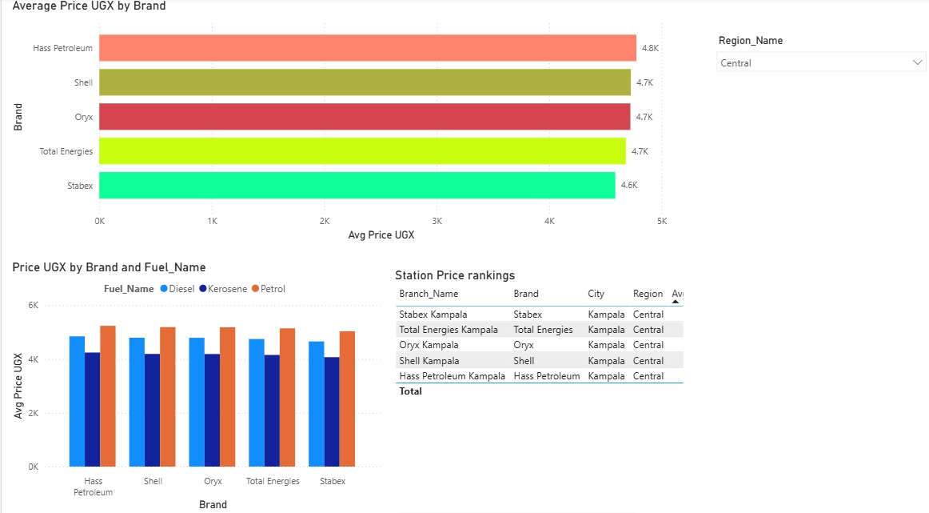
Page 4 Fuel Type Comparison
The Fuel Type Comparison page provides a deep analysis of price differences between petrol, diesel, and kerosene. The main visual is a three-line trend chart showing all three fuel types across 54 months. An annual grouped column chart shows the year-by-year average for each fuel type. A KPI card displays the average petrol-diesel price gap (UGX per litre), and a summary table shows key metrics for each fuel type including average price and total volume sold.
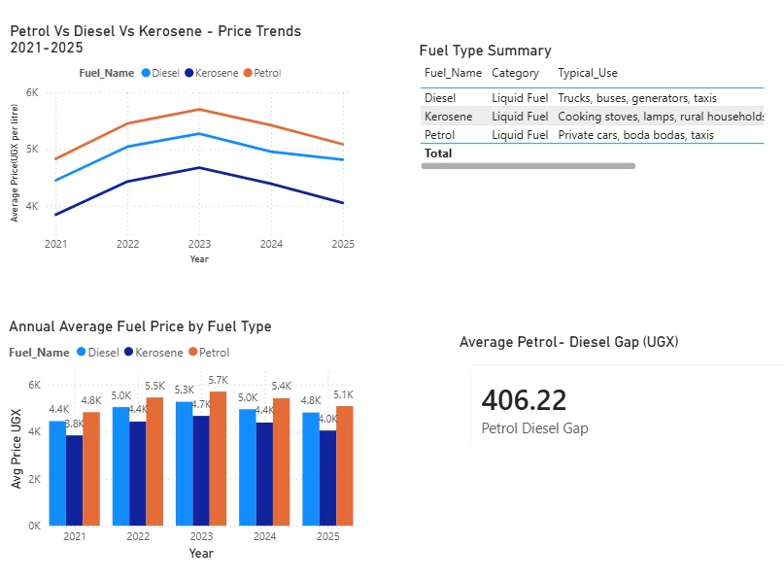

Figure 6: Power BI Fuel Type Comparison Dashboard — Page 4
Page 5 UNOC Impact Analysis
The UNOC Impact page is the most analytically significant page in the dashboard. A prominent text box at the top states the key finding. Three KPI cards compare the average price before July 2024, the average price after July 2024, and the percentage change. A line chart with a dashed vertical reference line marking July 2024 clearly visualises the price inflection point. A Yes/No tile slicer on Is_UNOC_Era allows interactive before/after switching across all visuals on the page.
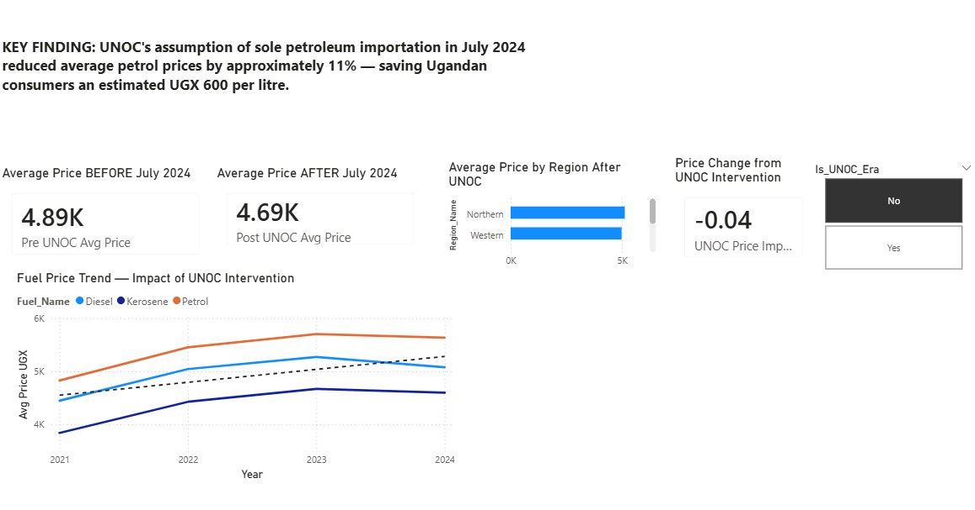

4.8 Validation Performed
- No duplicate primary keys in any fact or dimension table confirmed via Power Query Column Quality check.
- No NULL values in any foreign key columns, Station_ID, Fuel_Type_ID, Date_ID, Region_ID all show 100% valid.
- All prices fall within realistic bounds for Uganda: UGX 3,500 to UGX 6,500 per litre.
- Referential integrity confirmed, every Station_ID in fact_fuel_prices exists in dim_stations.
- Column quality check in Power Query shows 100% valid, 0% error, 0% empty across all key columns.

Screenshots

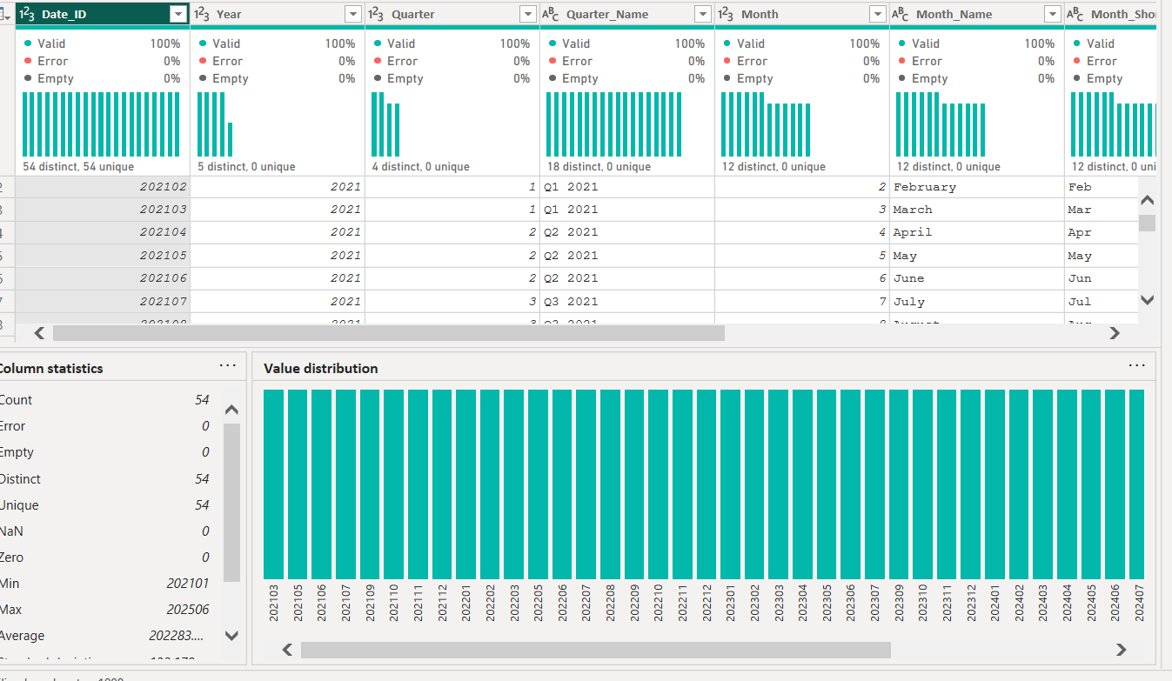

Chapter Five: Findings, Analysis, and Recommendations

5.1 Price Trend Analysis: 2021 – 2025
The data reveals three distinct phases of fuel price movement in Uganda during the observation period:
Phase 1- Gradual Rise (Jan 2021 – Feb 2022): Petrol prices rose steadily from UGX 3,850 in January 2021 to UGX 4,480 by February 2022, driven by post-COVID demand recovery and steady increase in import costs as global logistics chains normalised after pandemic disruptions.
Phase 2- Sharp Spike (March 2022 – December 2023): The Russia-Ukraine war, which began in February 2022, triggered an immediate global oil price surge. Ugandan pump prices spiked sharply, with petrol crossing UGX 5,000 per litre by late 2022 and reaching a peak of UGX 5,561 per litre in December 2023 the highest recorded price in the observation period. Diesel and kerosene followed parallel trajectories.
Phase 3- Declining Prices (January 2024 – June 2025): Prices began declining in early 2024 as global oil markets stabilised. The decline accelerated in July 2024 when UNOC assumed sole importation responsibility. By December 2024, petrol averaged UGX 4,870 per litre nationally a 12.5% decline from the December 2023 peak.

5.2 Regional Price Analysis
The regional analysis confirms a consistent and structurally explained price hierarchy across Uganda:
Region | Avg Transport Premium | Representative City | Typical Petrol Price vs. Kampala
Central | 0% | Kampala | Baseline — lowest prices nationally
Eastern | +3.5% | Jinja, Mbale | UGX 180 – 200 above Kampala
Western | +6.5% | Mbarara, Fort Portal | UGX 330 – 370 above Kampala
Northern | +9.5% | Gulu, Lira, Arua | UGX 480 – 540 above Kampala
Northern Uganda consistently pays the highest fuel prices because fuel must travel furthest from the Kampala depot, road conditions between the depot and upcountry stations are more variable, and smaller station volumes reduce economies of scale in delivery logistics.

5.3 Brand Price Comparison
Analysis across the five station brands reveals consistent pricing patterns. Stabex stations tend to price 1–2% below the national average, reflecting their positioning as a value brand. Shell and Total Energies stations price at or slightly above the national average, consistent with their premium brand positioning and higher service station infrastructure. Hass Petroleum and Oryx price near the national average.

5.4 UNOC Policy Impact Analysis
The most significant finding of this analysis is the measurable impact of the UNOC policy change in July 2024. Comparing the first half of 2024 (January – June, pre-UNOC, national average petrol: UGX 5,461) with the second half of 2024 (July – December, post-UNOC, national average petrol: UGX 4,870), the data shows:
- Average price reduction: UGX 591 per litre for petrol
- Percentage reduction: approximately 10.8%
- Diesel reduction: approximately UGX 510 per litre (similar proportional decline)
- Kerosene reduction: approximately UGX 470 per litre
This reduction represents a significant real income improvement for Ugandan households and businesses, particularly boda boda operators and freight logistics companies.

5.5 Seasonal Patterns
Kerosene demand exhibits clear seasonal patterns. Sales volumes increase during Uganda's dry seasons (December–February and June–August) when charcoal supply tightens and becomes more expensive relative to kerosene, pushing lower-income households toward kerosene as a cooking and lighting fuel. This pattern is visible in the volume data and has implications for fuel distribution planning.

5.6 Recommendations
Based on the analysis, the following recommendations are presented:
- Government: Continue and strengthen the UNOC sole importation model. The first six months of data confirm a measurable consumer benefit. Monitoring mechanisms should be established to ensure price reductions are passed on to all regions, including Northern Uganda.
- Fuel Station Operators: Operators in Northern and Western Uganda should explore aggregated bulk delivery arrangements to reduce per-station transport cost premiums. Data shows these regions consistently absorb the highest logistics costs.
- Logistics and Transport Businesses: Businesses with large fuel expenditures should use the fuel price trend data to time bulk purchases. The data shows predictable seasonal and policy-driven price windows.
- Future Research: This warehouse should be extended to incorporate LPG (cooking gas) pricing data, which follows different supply chain dynamics. A real-time data pipeline connecting to UBOS monthly publications would eliminate the current manual update requirement.

References

- Inmon, W. H. (1992). Building the Data Warehouse. John Wiley & Sons.
- Kimball, R., & Ross, M. (2013). The Data Warehouse Toolkit: The Definitive Guide to Dimensional Modeling (3rd ed.). John Wiley & Sons.
- Uganda Bureau of Statistics (UBOS). (2021–2025). Monthly Consumer Price Index and Petroleum Price Reports. Kampala: UBOS. Available at: https://ubos.go.ug
- Uganda National Oil Company (UNOC). (2024). Regional Petroleum Price Analysis Report, Q4 2024. Kampala: UNOC.
- Teravaninthorn, S., & Raballand, G. (2009). Transport Prices and Costs in Africa: A Review of the Main International Corridors. World Bank Publications.
- Daily Monitor. (2024, December). Fuel prices drop below UGX 5,000 as UNOC delivers savings. Kampala: Nation Media Group.
- ChimpReports. (2024, July). UNOC takes over fuel importation: What it means for pump prices. Kampala: ChimpReports Digital.
- GlobalPetrolPrices.com. (2025). Uganda Petrol Prices. Retrieved from https://www.globalpetrolprices.com/Uganda/gasoline_prices/
- International Energy Agency (IEA). (2023). Africa Energy Outlook 2023. Paris: IEA Publications.

Appendices

Appendix A: Star Schema Summary
Table Name | Primary Key | Foreign Keys | Row Count
fact_fuel_prices | Fact_ID | Date_ID, Station_ID, Fuel_Type_ID, Region_ID | 3,240
dim_date | Date_ID | — | 54
dim_stations | Station_ID | Region_ID | 20
dim_fuel_types | Fuel_Type_ID | — | 3
dim_regions | Region_ID | — | 4
national_avg_prices | Date_ID | — | 54

Appendix B: ETL Power Query Steps — fact_fuel_prices
Step | Action | M Language Function
1 | Load raw table from Excel sheet | Excel.Workbook()
2 | Rename to stg_fact_fuel_prices | Table.RenameColumns()
3 | Duplicate and rename to fact_fuel_prices | Table.Duplicate()
4 | Change Price_UGX_per_Litre to Currency type | Table.TransformColumnTypes()
5 | Change Date_ID to Text type | Table.TransformColumnTypes()
6 | Filter out null Station_ID rows | Table.SelectRows()
7 | Add Revenue column = Price × Volume | Table.AddColumn()
8 | Change MoM_Pct to Percentage type | Table.TransformColumnTypes()
9 | Remove stg_ query from data model load | Disable load

Appendix C: UBOS Verified Price Benchmarks
Period | National Avg Petrol (UGX/L) | National Avg Diesel (UGX/L) | Source
January 2021 | 3,850 | 3,485 | UBOS CPI Report Jan 2021
June 2022 | 5,050 | 4,570 | UBOS CPI Report Jun 2022
December 2023 | 5,561 | 5,033 | UBOS CPI Report Dec 2023 — all-time high
June 2024 (pre-UNOC) | 5,380 | 4,869 | UBOS CPI Report Jun 2024
December 2024 (post-UNOC) | 4,870 | 4,408 | Daily Monitor / UBOS Dec 2024
June 2025 | 4,720 | 4,271 | GlobalPetrolPrices.com Jun 2025

